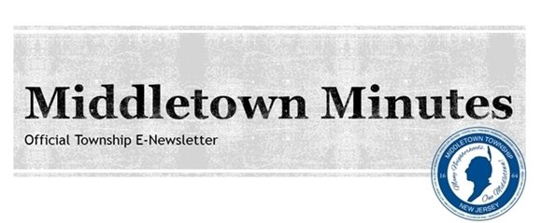

Middletown Township Proclaims
September 15, 2018 Usher Syndrome Awareness Day

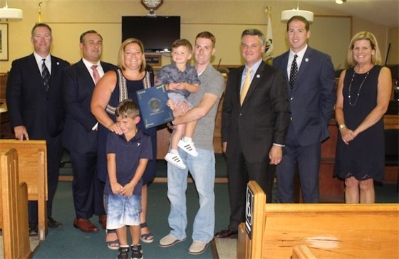
On Tuesday, September 4th, Mayor Kevin Settembrino and the Township Committee presented Lisa, Brian, Flynn, and Gunnar Henschel with a proclamation recognizing Saturday, September 15, 2018 as Usher Syndrome Awareness Day in the Township of Middletown. Three-year-old Gunnar (who is being held by his father in the photo) has Usher syndrome and they are hoping that the community can help raise awareness about this disease, which is presently incurable. Usher syndrome is a relatively rare genetic disorder caused by a mutation in any one of at least 10 genes resulting in a combination of hearing loss and visual impairment, and is a leading cause of combined deafness and blindness. More than 400,000 people are affected by this genetic disorder worldwide, with up to 50,000 of those in the United States. We commend the Henschels and their extended family for their commitment to raising awareness about this condition for all those who are affected. We are all here to support Gunnar!
Pictured from Left: Committeeman Rick Hibell, Deputy Mayor Tony Fiore, Lisa Henschel, Flynn and Gunnar Henschel, Brian Henschel, Mayor Kevin Settembrino, Committeeman Tony Perry, and Committeewoman Pat Snell.

Leonardo Beach Party Was a Great Way to Say Farewell to Summer

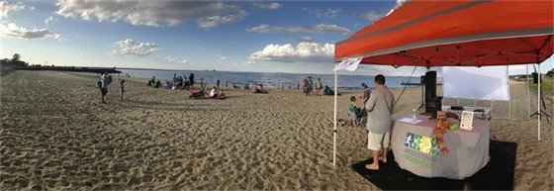

The Middletown Recreation Department held its annual Leonardo Beach Party on Thursday, August 30th. Residents enjoyed the beautiful weather along with music, games, and more. Representatives from the Middletown Township Public Library were at the event to distribute library cards, and the Leonardo First Aid and Rescue Squad was there to meet some locals and share information about upcoming events. After the party, families stayed to watch the Movie in the Park Series featuring "Sherlock Gnomes".

Moment of Silence and Wreath Tribute to Be Held on Tuesday, September 11th

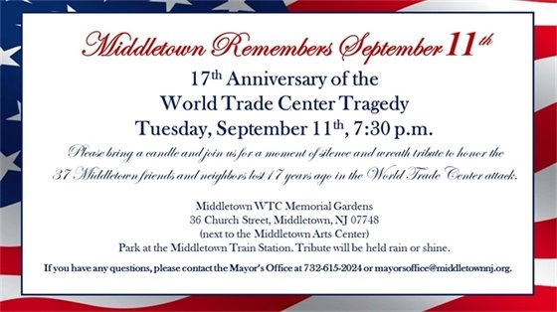

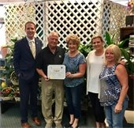
Koch Florist & Gifts owners Bill and Gail Bechtoldt proudly hold their "Made in Middletown" Small Business Appreciation Award.
Pictured from left: Committeeman Tony Perry, business owners Bill and Gail Bechtoldt, Committeewoman Pat Snell, and store manager Michelle McDonald.

Township Presents "Made in Middletown" Small Business Appreciation Certificate to
Koch Florist & Gifts

On Thursday, September 6th, Committeeman Tony Perry and Committeewoman Pat Snell stopped by Koch Florist & Gifts to present business owners Bill and Gail Bechtoldt with a "Made in Middletown" small business appreciation award on behalf of the Township Committee. This initiative began in May 2018 to help spotlight local small businesses that are vital to our town's economy.
Koch Florist & Gifts has been a small family business in Middletown for almost 60 years and has been the go-to business for personalized, fresh floral arrangements. Our town has also benefited from their outstanding community service through programs such as the Rainbow Foundation and Jersey Shore Workcamp. Thank you for being Made in Middletown!



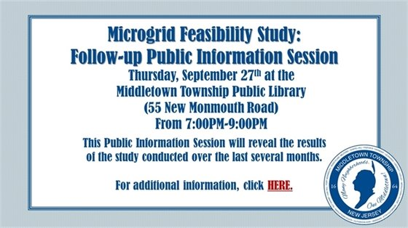

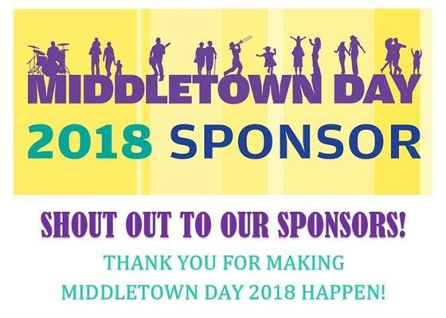
We want to take a moment to thank our Gold Plus, Gold, Silver and Bronze sponsors for supporting Middletown Day 2018. Middletown Day will be held rain or shine on Saturday, September 22nd from 11:00 a.m.- 5:00 p.m. at Croydon Hall (900 Leonardville Road, Leonardo).
*GOLD PLUS*
T&M
*GOLD*
Archer & Greiner, P.C.
O'Toole, Scrivo, Fernandez, Weiner, Van Lieu, LLC
*SILVER*
Century 21 Thomson & Company
Columbia Bank
Memorial Sloan Kettering Cancer Center
Middletown Township Public Library
Middletown Township Education Association
Orange Theory Fitness Studio
Provident Bank
*BRONZE*
CME Associates
Foley Prep
Maser Consulting P.A.
Middletown Family Pharmacy
MRC - GameTime
Saker ShopRites
Sodon's Electric
The Community YMCA

Check Out These Great Events!

  
  MTPL Presents: Star Party Astronomy Observing!
  Star Gazing Event presented by S.T.A.R. Astronomy Group will take place in our staff parking lot. This group brings out their professional telescopes to allow for excellent sky viewing!
  Date: Thursday, September 13th
  Time: 7:00-9:00PM
  Location: MTPL Staff Parking Lot (55 New Monmouth Road)
  Click on the picture for more info!
  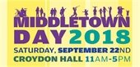
  Middletown Day will return to the Great Lawn at Croydon Hall this year on Saturday,
  September 22nd!
  NEW THIS YEAR: There will be a new pirate ship called "The Black Pearl" featuring live shows, and Crunchy the T-Rex will be there to entertain the kids!
  Back this year is the Business and Community Showcase, familiar favorites such as the Inflatable Fun Zone, carnival games, a full food court featuring a variety of vendors, Fire Department demonstrations, live entertainment, a petting zoo, a pie eating contest and more. Please join us!
  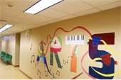
  Sign Up Today for A Day Off From School Camp!
  September 10, 19, October 8, November 5-9
  Each day includes creative adventures in a day-camp setting designed to enrich your child's curriculum during those days when school is not in session. Featuring the Doodle Dude, Miss Fish and Guest Instructors.
  Full and Half Day Sessions available. Pre-registration is required. Call 732-706-4100 or click on the image to learn more and register.

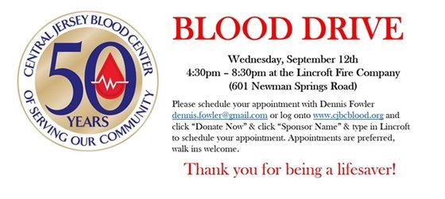
Click the picture to make an appointment!

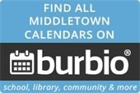

Get Organized for Fall: Community, School & More

As summer comes to a close, it's time to start thinking about getting organized for the upcoming fall season. Use Burbio.com, a free website and app that puts Middletown community, government, school & school sports and library events all in one place. With Burbio.com you can select calendars to follow, create a personalized event feed, sync events to your personal calendar instantly, and get notified when things change!

Sign up at: www.Burbio.com or download the app for iPhone or Android

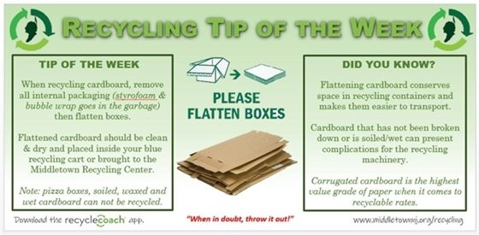

CORRECTION NOTICE: MTFD Annual Fire Picnic Caption

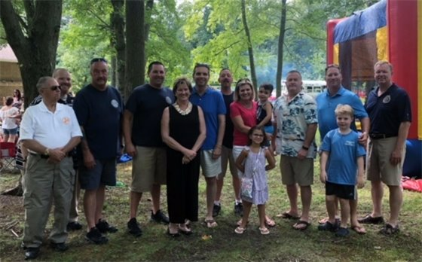
In last week’s e-newsletter, the caption below the MTFD Annual Picnic incorrectly identified 3rd Assistant Fire Chief Bernie Chenoweth as Special II Officer Dave Chenoweth. We apologize for the error and thank Chief Chenoweth for his dedication to our community as a volunteer firefighter!
REVISED CAPTION (pictured from left): Office of Emergency Management Director, Charlie Rogers, Assistant EMS Chief Jim Kelly, 2nd Assistant Fire Chief John Friedmann, Fire Chief Ryan Clarke, Hazlet Deputy Mayor Sue Kiley, Freeholder Gerry Scharfenberger, Deputy Fire Chief Steve Schweizer, Committeewoman Pat Snell and her grandchildren, 3rd Assistant Fire Chief Bernie Chenoweth, Committeeman Rick Hibell and his son, and Police Chief Craig Weber.

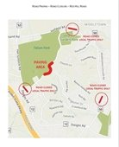
Click HERE to see a larger version of the map.

Roadwork and Detours

Road Paving Notice: Red Hill Road Closure on Monday, 9/10

Red Hill Road will be closed for paving between Deepdale Drive and Church Lane on Monday, September 10, 2018 from approximately 6:00 a.m. to 6:00 p.m., weather permitting.
This project is being performed by the Monmouth County Highway Department under the County's shared services agreement with Middletown Township.
Traffic will be detoured through Holland Road, Middletown-Lincroft Road, and Dwight Road accordingly. Bamm Hollow Road will be closed except for local traffic.
Tatum Park and Deep Cut Gardens will be open.
If you have any questions, please contact the Middletown Township Police Department at 732-615-2100.

  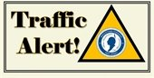
  Road Restoration Work for New Jersey American Water Continues on the Following Streets:
  - Avenue A
  - Ataboy Ave.
  - Gordon Ct.
  - Avenue D
  - High Boy Ave.
  - Walada Ave.
  - Wood Ave.
  - Carter Ave.
  - Avenue B
  - Handy Boy Ave.
  - Plymouth Ave.
  - Georgia Ave.
  - Orphan Boy Ave.
  - Bergen Ave.
  If you have any questions, contact
  Traffic at 732-615-2045.

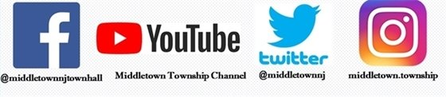

Facebook Twitter Instagram Youtube

Verizon FiOS Channel 26/Comcast Cable Channel 20

  Share on Facebook
  Share on Twitter
  Share via Email

  Copyright 2015 Middletown NJ. All Rights Reserved.
  1 Kings Highway, Middletown, NJ 07748
  If you no longer wish to receive emails from us, you may Unsubscribe.
  Powered by

Email not displaying correctly? View it in your browser.

