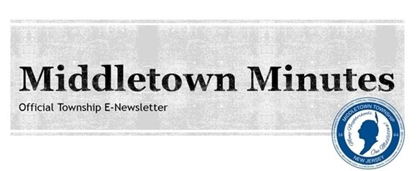

Middletown Remembers Fallen Soldiers with Annual Memorial Day Parade

  
  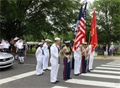
  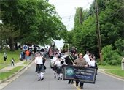

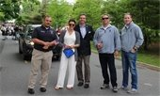
Committeeman Tony Fiore, Mayor Steph Murray, Freeholder Gerry Scharfenberger, and Committeemen Rick Hibell and Tony Perry stepping off at the parade.

American Legion Post 338 and Middletown Township held its annual Memorial Day Parade on Monday, May 28th to honor those who have fallen in the line of duty. Navy veteran Ron Stark served as the Grand Marshall of the parade while hundreds of residents lined the streets to honor and remember the men and women who served our nation and gave their lives for our freedom. Many thanks to the fire houses, Police Explorers, high school bands, bagpipers, Scout troops, and other organizations who participated in this beautiful tribute.
After the parade, there were several speakers at American Legion Post 338 who reminded the community about the importance of Memorial Day and paying homage to those who made the ultimate sacrifice for our country. This was followed by a laying of wreaths, rifle squad, and playing of Taps.
Click HERE or on the pictures to view more photos from the Memorial Day Parade!

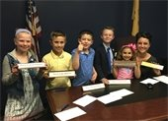

Click HERE or on the picture to watch the latest "Minute with the Mayor" video segment featuring our Mayor for a Day winners.

Township Happenings & Events

  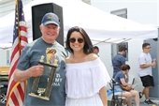
  Mayor Steph Murray attended the Port Monmouth Fire Company Car Show this past Saturday, May 27th and presented the "Mayor's Choice" award to Robert Ferguson. The car show raises money for pancreatic cancer research. Thank you to everyone who participated in making the event a success!
  
  Committeeman Tony Perry and Freeholder Gerry Scharfenberger congratulated recent Project P.L.U.S. graduates on Wednesday, May 30th at Croydon Hall. Fifth grade students from local elementary schools participated in the 7-week Project P.L.U.S. (Peer Leaders Understanding Students) after-school drug awareness program. Thank you to all of the staff and volunteers who make this program possible!
  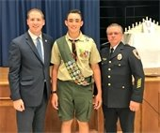
  Committeeman Tony Perry and Deputy Chief Robert Stefanski attended the Eagle Scout Ceremony for Tyler McKinney of Troop 110 at Lincroft Elementary School on Wednesday, May 30th. Tyler's community service project benefited Grandview Apartments in Keansburg and included installing new benches,creating raised garden beds,re-tarring pavement, and planting trees in their garden. Congratulations and best of luck in the future!

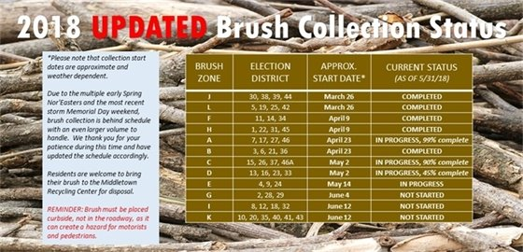

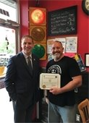
Committeeman Tony Perry thanks Red Light Coffee Owner Jeff Lewis for being "Made in Middletown".

Red Light Coffee Receives "Made in Middletown" Small Business Certificate

Committeeman Tony Perry stopped by Red Light Coffee & Espresso Bar in Lincroft to present owner Jeff Lewis with a Small Business Appreciation certificate. The Middletown Township Committee recently launched the "Made in Middletown" initiative to spotlight and appreciate small local businesses that are so vital to our town's economy.
Red Light Coffee has been serving the Middletown area for the past three years with their coffees, teas, and treats. Click HERE or the picture to visit their website.

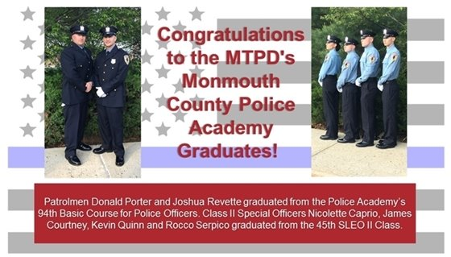

The MTFD Teams Up with Infinite Love for Kids Fighting Cancer For Shave a Hero//Save a Hero Fundraiser THIS SATURDAY, 6/2!

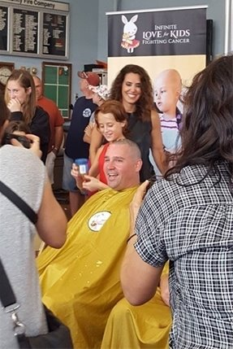
Middletown Township Fire Department Chief Ryan Clarke (pictured above) was one of the many individuals who participated in Infinite Love for Kids Fighting Cancer's "Shave a Hero//Save a Hero" event last summer. The MTFD will be teaming up again with the organization at this year's event which will be held on Saturday, June 2nd from noon – 4:00PM (rain date June 3rd) at the Community Firehouse Station #4 (75 Appleton Avenue Leonardo, NJ). Click on the picture to learn more about Infinite Love and how to participate in this event that will help kids fight cancer one bald head at a time.

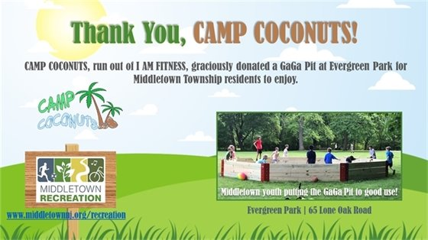

  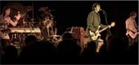
  The Middletown Township Public Library Presents: The Wag Pop Music Concert!
  Date: Tuesday, June 5th
  Time: 7:00 PM- 8:00 PM
  Location: MTPL Community Room (55 New Monmouth Road)
  Click the picture for more information!
  
  Middletown Recreation Department Presents: Community Science at Poricy Park!
  Date: Saturday, June 16th
  Time: 3:00PM- 4:00PM
  Location: Poricy Park (345 Oak Hill Road)
  Click the picture to learn more!
  
  The Middletown Arts Center Presents: Elements of Abstraction
  Date: Sunday, June 10th
  Time: 1:00 PM- 5:00 PM
  Location: Middletown Arts Center (36 Church Street)
  Call 732-706-4100 for pricing and to register or click the picture to learn more!

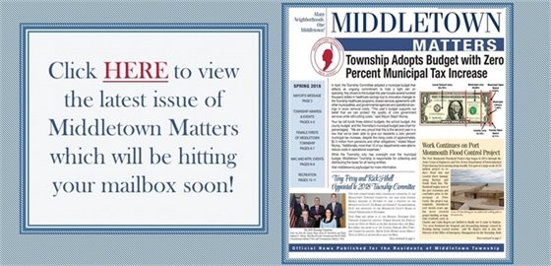

  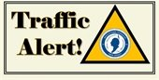
  Roadwork & Detours
  Maintenance Work on West Front Street at the Garden State Parkway Overpass on
  5/31 and 6/1
  Maintenance work will be starting on West Front Street on the Garden State Parkway overpass this Thursday, 5/31 and Friday, 6/1, and will potentially continue into next week. There will be a single lane closure during this time between the hours of 7:00 a.m. and 4:00 p.m..
  GSP Exit Ramp 109 Northbound Will Be Closed Overnight on 6/1
  The Garden State Parkway Exit Ramp 109 Northbound will be closed between the hours of 9:00 p.m. and 5:00 a.m. on Friday, 6/1 and Saturday morning, 6/2 for road maintenance. Travelers are advised to take Exit 114 which will remain open.
  Roadwork on Kings Highway & Church Street
  There is significant roadwork being done on Kings Highway and Church Street in preparation of the signalization of the roadway. Kings Highway will have lane shifts in place and Church Street will have intermittent closures between 9:00 a.m. and 4:00 p.m. from Monday, 6/4 through Friday, 6/8. Detours will be in place to follow. Please plan alternate routes.
  Road Restoration Work for New Jersey American Water Continues on the Following Streets:
  - Avenue A
  - Ataboy Ave.
  - Gordon Ct.
  - Avenue D
  - High Boy Ave.
  - Walada Ave.
  - Wood Ave.
  - Carter Ave.
  - Avenue B
  - Handy Boy Ave.
  - Plymouth Ave.
  - Georgia Ave.
  - Orphan Boy Ave.
  - Bergen Ave.
  If you have any questions, contact
  Traffic at 732-615-2045.

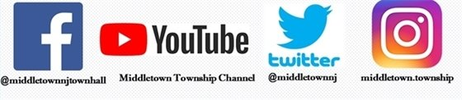

Facebook Twitter Instagram Youtube

Verizon FiOS Channel 26/Comcast Cable Channel 20

  Share on Facebook
  Share on Twitter
  Share via Email

  Copyright 2015 Middletown NJ. All Rights Reserved.
  1 Kings Highway, Middletown, NJ 07748
  If you no longer wish to receive emails from us, you may Unsubscribe.
  Powered by

