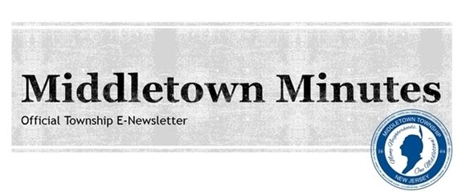

Reminder: Microgrid Feasibility Study Public Information Session Tonight from 7-9PM

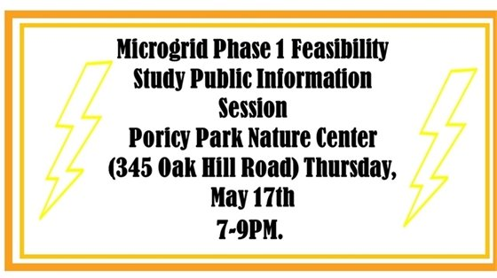
Click the picture to learn more!

Middletown Celebrates Police Week!

  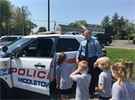
  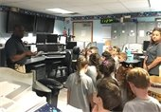
  

The Middletown Township Police Department participated in National Police Week, which happens every year during the week of May 15th, to recognize the service and sacrifice of U.S. law enforcement.
The MTPD provided tours of the department to residents, students, and anyone interested in seeing how the justice system works in our Township. Officers walked groups through the process of what happens when someone calls 911 and a police officer is dispatched to an emergency. This included a tour of Middletown's former Emergency Call Center, the in-house jail, the courtroom, and a patrol car.
The Police Department will be holding its annual memorial service on Friday, May 18th at 11:00 a.m. at the Police Memorial located at Town Hall (1 Kings Highway) to honor deceased officers. The public is invited to attend.
Photos (above): Detective Darrin Simon and Corporal Ryan Riffert gave a tour of the Police Department and Patrolman Riffert's patrol car to a group from St. Mary's School.

  
  Officer Ray Sofield, K-9 Nero, and Detective Keith Hirschbein with Middletown Preschool's PreK class at the Tonya Keller Community Center.
  Detective Keith Hirschbein, Officer Ray Sofield and K-9 Nero took time out of their morning to visit with the PreK3 and PreK4 classes at Middletown Preschool on Tuesday, May 15th.
  Some of the highlights of their visit were the K-9 demonstrations and turning on the siren for the children in the patrol car.
  
  Detective Keith Hirschbein spoke with the preschool students about how the police department works to keep our community safe.


Come join the fun! The Town-Wide Garage Sale is this Saturday & Saturday, May 19th and 20th between 8:30AM-4:30PM. Click the picture to register or learn more!

Middletown Holds Annual Reaching Out Program
for Drug Awareness

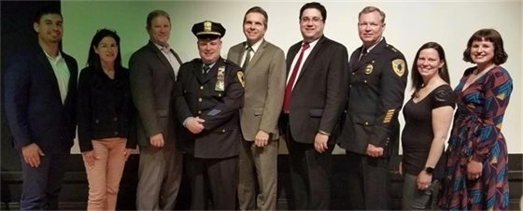
2018 Reaching Out Program (pictured from left): Andrew Suarez, recovering addict, Kathleen Brooks, mother of an addict, Township Administrator Tony Mercantante, Detective Danny Sullivan, Freeholder Gerry Scharfenberger, Bill Bucco, Acting Deputy Director Monmouth County Mental Health & Addiction Services, Police Chief Craig Weber, Crossroads Program Director Angela Pepe-Lage, and Rebecca Rean, Drug Counselor at Middletown's Substance Abuse Division and Crossroads.

On Monday, May 14th, the Middletown Health Department, Crossroads, and the Middletown Municipal Alliance held its annual Reaching Out Program at the Middletown Arts Center to present the most current issues and topics concerning drugs and alcohol in the community. Panelists, comprised of Middletown municipal departments, the Middletown Board of Education, and County agencies, educated parents and 5th grade students about the role they play in the daily battle against drug and alcohol use. There were also special speakers who shared real-life stories about how drugs and alcohol have had a direct impact on their lives, and cyber bullying specialist Nicki Frances gave a presentation about the dangers of social media and Internet safety. The program is geared towards showing students about to enter middle school how one bad choice can ruin their life as well as the lives of those around them.
Thanks to all who came out to support the program's initiatives!



Has Your Private Hauler Retrieved Your Trash Can?

If your former private hauler has not retrieved your trash receptacle, please email your name and address to recycling@middletownnj.org with the subject head “Cart not retrieved”. The Township will forward your information to the NJ Department of Environmental Protection since they have taken enforcement action.

The MTFD Teams Up with Infinite Love for Kids Fighting Cancer For Shave a Hero//Save a Hero Fundraiser: Saturday, 6/2!

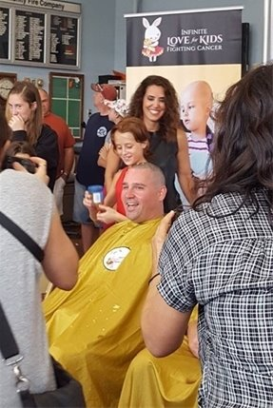
Middletown Township Fire Department Chief Ryan Clarke (pictured above) was one of the many individuals who participated in Infinite Love for Kids Fighting Cancer's "Shave a Hero//Save a Hero" event last summer. The MTFD will be teaming up again with the organization at this year's event which will be held on Saturday, June 2nd from noon – 4:00PM (rain date June 3rd) at the Community Firehouse Station #4 (75 Appleton Avenue Leonardo, NJ). Click on the picture to learn more about Infinite Love and how to participate in this event that will help kids fight cancer one bald head at a time.

  
  The Middletown Township Public Library Presents: Travis Walton-The Movie Screening & Q&A About a UFO Encounter
  Date: Saturday, May 26th
  Time: 12:30 PM- 4:30 PM
  Location: MTPL Community Room (55 New Monmouth Road)
  Click the picture for more information!
  
  Middletown Recreation Department Presents: Community Science at Poricy Park!
  Date: Saturday, May 19th
  Time: 3:00PM- 4:00PM
  Location: Poricy Park (345 Oak Hill Road)
  Click the picture to learn more!
  
  The Middletown Arts Center Presents: Elements of Abstraction
  Date: Sunday, June 10th
  Time: 1:00PM-5:00PM
  Location: Middletown Arts Center (36 Church Street)
  Call 732-706-4100 to register or click the picture to learn more!

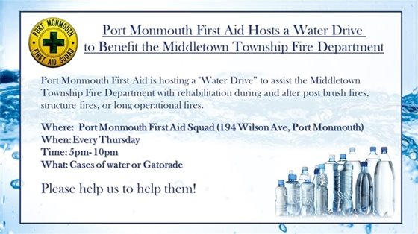





Traffic Alerts for May 19th and 20th: Keep an Eye Out for 5K Runners!
On Saturday, May 19th, the St. Mary's Athletic Association and The Jersey Shore Running Club will be holding a “Spring Into Summer” 5K. The 5K will begin at 8:30AM at Saint Mary’s School and run along Cherry Tree Farm Road and Wilson Avenue.
On Sunday, May 20th, the Lincroft PTA will be hosting a “Leopards on the Loose” 5K. The run/walk will begin at the Lincroft Village Green at 8:30AM and continue along Swimming River Road and Phalanx Road.
There will be members of the Middletown Township Police Department at both events to help direct traffic. We ask that residents be aware of runners and potential traffic and drive with caution.
Call 732-615-2045 with any questions/concerns.

  
  Roadwork & Detours
  Roadwork on Kings Highway & Church Street
  There is significant roadwork being done on Kings Highway and Church Street in preparation of the signalization of the roadway. Kings Highway will have lane shifts in place and Church Street will have intermittent closures between 9:00 a.m. and 4:00 p.m. from Monday, 5/21 through Friday, 5/25. Detours will be in place to follow. Please plan alternate routes.
  The following road restoration work for New Jersey American Water is planned for the following streets in Middletown:
  Avenue A Carter Ave Ataboy Ave Avenue B Gordon Ct. Handy Boy Ave
  Avenue D Plymouth Ave High Boy Ave Georgia Ave Walada Ave Orphan Boy Ave
  Wood Ave Bergen Ave
  If you have any questions, contact
  Traffic at 732-615-2045.



Facebook Twitter Instagram Youtube

Verizon FiOS Channel 26/Comcast Cable Channel 20

  Share on Facebook
  Share on Twitter
  Share via Email

  Copyright 2015 Middletown NJ. All Rights Reserved.
  1 Kings Highway, Middletown, NJ 07748
  If you no longer wish to receive emails from us, you may Unsubscribe.
  Powered by

