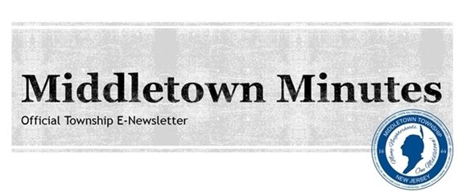

Hometown Sports Hero Award Presented to Middletown High School South Alum and Super Bowl Champ
Rick Lovato

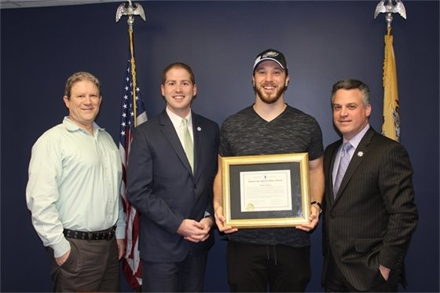
Middletown welcomed home Philadelphia Eagles Super Bowl champ and Middletown High School South alum Rick Lovato at Town Hall on April 4th and proudly presented him with the 'Hometown Sports Hero Award'. Mr. Lovato is a 2011 graduate of Middletown High School South where he was an All-Conference lineman for the MHSS Eagles. Before signing with the Eagles as a long snapper in 2016, he played for the Chicago Bears, Green Bay Packers and the Washington Red Skins. He was an integral part of the 2017 team and ultimately joined his teammates in winning the Super Bowl against the New England Patriots on February 4th, bringing the city of Philadelphia it’s first Lombardi Trophy in history. We congratulate him and wish him continued success!
Pictured from left: Township Administrator Tony Mercantante, Committeeman Tony Perry, Philadelphia Eagles player Rick Lovato, and Deputy Mayor Kevin Settembrino.

Nominate Middletown to Win a $20K Grant
for a Local Park!

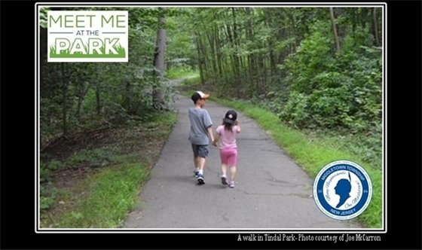
Our local parks help make #MiddletownNJ awesome! With your help, we can make one of our local parks even better. Nominate our town to win a $20,000 grant during #EarthMonth at www.NRPA.org/DisneyMeetMeAtThePark. Click the picture to vote! #MeetMeAtThePark#CelebrateEarth

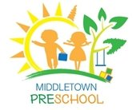
Click the picture to learn more!

Middletown Preschool Registration for the 2018-19 School Year Has Begun!
Middletown Preschool offers a variety of programs for children ages 18 months to Pre-Kindergarten. The age-appropriate curriculum includes social skills, arts & crafts, stories, music, numbers, letters, shapes, colors, science, sight words, writing skills, physical education and games.
All classes run from September through June. The schedule runs parallel to the Middletown Board of Education schedule. Please be aware that the age of your child on October 1, 2018 will determine the class he/she will be registered.
Programs Include:
Young Toddlers - Parent & Me
Mondays 9:30am - 11:30am
This is a parent-child class for children ages 18-35 months
$650 per school year *
3 Year-Olds
Tuesday - Thursday 9:30am-12:00pm
$2,150 per school year *
Pre-Kindergarten
Monday - Thursday 9:00am-12:00pm
This structured program teaches Kindergarten readiness skills
$2,750 per school year *
All classes held at the Tonya Keller Community Center located at 50 Bray Avenue, Middletown, NJ 07748
*Prices are subject to change.
Call 732-615-3230 or visit www.middletownnj.org/signup to register.

Middletown Preschool Playdates Program
Need two hours of kid-free time during the week to get errands done? Preschool Playdates is a great place to drop off your 3-5 year-old in a supervised “playdate” setting. The program runs Monday-Thursday at the Tonya Keller Community Center from 12:00 to 2:00 p.m. The next session is from April 30-June 7. The fee is $131.
Your child does not have to be enrolled in Middletown Preschool to participate in this program, however pre-registration is required. Visit www.middletownnj.org/signup to register online.

Township Happenings and Events

  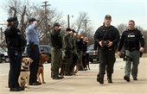
  Middletown Police Officer Brian McGrogan and K-9 Jax attended the memorial service for Salem County Sheriff’s K-9 Roxy at the Salem County FOP on Thursday, March 29th. Roxy was a member of the Salem County Sheriff’s Office since 2010 and was involved in over 500 drug investigations. We thank all the K-9s and their handlers for the hard work they do in our communities! Photo courtesy of Al Amrhein for NJ Advance Media.
  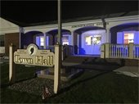
  In honor of Autism Awareness Month, Middletown Town Hall is taking part in the #LightItUpBlueinitiative to raise awareness for people with Autism. Click the picture to visit the National Autism Association website and learn more.
  
  Check out the latest Minute with the Mayor segment filmed on Tuesday, March 14th at the Lincroft Fire Company. Middletown's fire chiefs, volunteer firefighters and Township Committee members joined Mayor Murray to discuss local news and events in Middletown. Click the picture to watch the video!

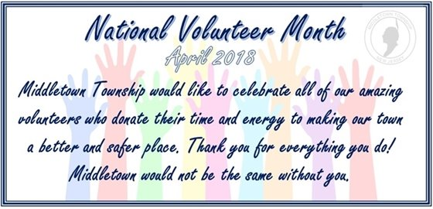

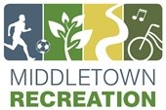

New This Summer: Trip Camp!

Formerly known as Trail Blazers/Navigators, teens will go on various field trips in this newly-renovated program for grades 7, 8 and 9. All trips will begin and end at the Tonya Keller Community Center (50 Bray Avenue). Registration is done per week, not per trip. The fee is $225 per week (Monday-Thursday). Visit this link and click on Grades 7-8-9 to view Week 1 through Week 6.
Visit www.middletownnj.org/signup to register.

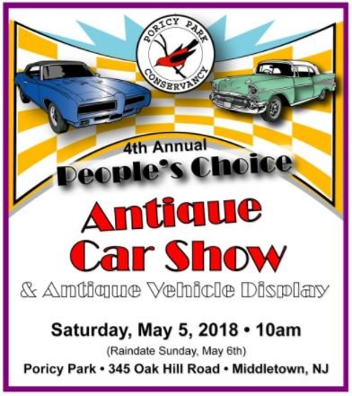
Click on the picture to learn more about the 4th Annual Antique Car Show at Poricy Park!

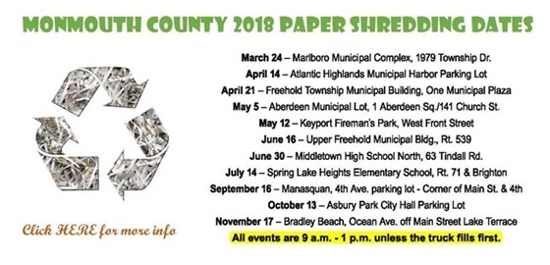
Click the picture to learn more!

  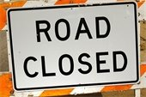
  Roadwork on Kings Highway & Church Street
  There is significant roadwork being done on Kings Highway and Church Street in preparation of the signalization of the roadway. Kings Highway will have lane shifts in place and Church Street will have intermittent closures between 9am and 4pm from Monday, 4/9 through Friday, 4/13. Detours will be in place to follow. Please plan alternate routes. If you have any questions, contact Traffic at 732-615-2045.

  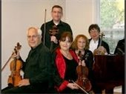
  The Middletown Township Public Library Presents: Holocaust Remembrance Day Concert by the Radiance Chamber Ensemble
  Date: Thursday, April 12th
  Time: 7:00 PM- 8:00 PM
  Location: MTPL Community Room (55 New Monmouth Road)
  Click the image for more info!
  
  Middletown Recreation Department presents: Town Wide Garage Sale!
  Date: Saturday & Saturday, May 19th and 20th
  Time: 8:300AM- 4:00PM
  Location: Town Wide!
  Click the picture to learn more!
  
  The Middletown Arts Center presents: Painting Ocean Waves - One Day Workshop
  Dates: Sunday, April 15th
  Time: 9:00AM- 5:00PM
  Location: Middletown Arts Center (36 Church Street)
  Please call 732-706-4100 to register or click the picture to learn more!


Click on the picture to learn more about the Middletown Township Home Energy Audit Program.

Stay up-to-date on the latest news and events from
Middletown Town Hall...

Click the links to go to the page and follow/ subscribe!

Facebook Twitter Instagram Youtube

Verizon FiOS Channel 26/Comcast Cable Channel 20

  Share on Facebook
  Share on Twitter
  Share via Email

  Copyright 2015 Middletown NJ. All Rights Reserved.
  1 Kings Highway, Middletown, NJ 07748
  If you no longer wish to receive emails from us, you may Unsubscribe.
  Powered by

