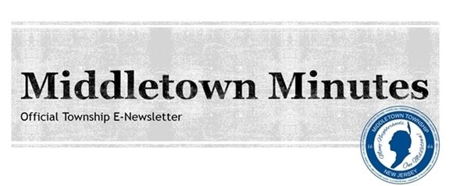

  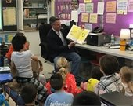
  Deputy Mayor Kevin Settembrino read to third grade students at Leonardo Elementary School on Read Across America Day. Read Across America Day is a nationwide reading celebration that takes place annually on March 2nd, the birthday of beloved children's book author, Dr. Seuss.
  Middletown Celebrates
  Read Across America!
  Deputy Mayor Kevin Settembrino and Committeeman Tony Perry visited local elementary schools this week to celebrate Read Across America, a nationwide event that celebrates reading and imagination.
  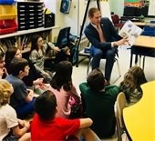
  Committeeman Tony Perry read to fifth grade students at River Plaza Elementary School on Thursday, March 1st in celebration of Read Across America.

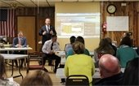
Leonardo resident and Committeeman Rick Hibell speaks to residents at the NCBL.

Leonardo Residents Launch Neighborhood Committee for a Better Leonardo Group

Residents of Leonardo came together Tuesday night for the first meeting of the Neighborhood Committee for a Better Leonardo (NCBL).
The NCBL is a resident action group that consists of locals from Leonardo who seek solutions for their shared problems at the community level. The mission of the group is to create positive change and greater communication within the neighborhood. Committeemen Tony Perry and Rick Hibell, Township Administrator Tony Mercantante, Police Chief Craig Weber and Deputy Chief Robert Stefanski attended the meeting to answer questions residents had regarding township or police related issues.
We are proud to have residents who are active and involved in their community! Visit the NCBL Facebook page for more information.

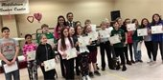
Mayor Stephanie Murray and Freeholder Gerry Scharfenberger congratulated the graduates of Project Plus.

Congratulations to the 5th Grade Project Plus Graduates!
Mayor Stephanie Murray spoke at the Project Plus graduation on Wednesday, February 28th at Croydon Hall. Fifth grade students from Harmony, Ocean Avenue, New Monmouth, and Port Monmouth Elementary schools participated in the 7-week Project P.L.U.S. (Peer Leaders Understanding Students) after-school drug awareness program. Thank you to all of the staff and volunteers who make this program possible!

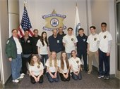
The Middletown EMS cadets are: Top row, from left to right:
Robert Pfleger, Deputy EMS Chief, Mike Depalma, Cadet Adviser, Chris Boeckle, Fairview First Aid, Dive Captain, Lauren Guisa, EMS Cadet, Richard Yarczower, Lead Adviser, Frank Brancati, Cadet Adviser, Jon Occhipinti, EMS Cadet, Liam Musa, EMS Cadet, Luke Croken, EMS Cadet, Rudra Amin, EMS Cadet.
Bottom row, left to right:
Olivia Enny, EMS Cadet President, Emily Cahill, EMS Cadet, Sophia Ziajski, EMS Cadet, Colette Lichtenstein, EMS Cadet.

Middletown's EMS Cadets Visit Monmouth County Sheriff's Office
The Middletown EMS Cadets took a tour of the Monmouth County Sheriff's facility in Freehold on Sunday, February 25th. The purpose of the visit was to educate the cadets on what happens in the 9-1-1 Communications Center and the role dispatchers play in an emergency.
The EMS Cadets are a group of young men and women ages 14 through 18 who are taught the basics of being a Middletown EMS worker by current EMS volunteers. The program lasts 4 years and cover a wide rage of life-support and first aid skills.

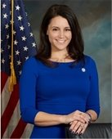

Mayor's Open Office Hours
MONDAY, MARCH 5TH
Mayor Stephanie C. Murray holds open office hours on the first Monday of the month from 5:00PM to 6:30PM at Town Hall, 1 Kings Highway. Visitors are seen on a first-come basis. Mayor Murray is also available by appointment. Please call 732-615-2024 for more information.

  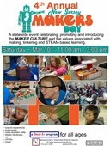
  The Middletown Township Public Library Presents:
  MAKERS DAY
  Date: Saturday, March 10th
  Time: 10:00AM - 3:00PM
  Location: MTPL Community Room (55 New Monmouth Road)
  Click the image for more info!
  
  SUMMER CAMP EMPLOYMENT OPPORTUNITIES
  To apply for a position, download our application by clicking on this image above. Applications are accepted at any time. Summer Camp interviews will begin in early spring.
  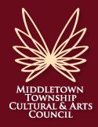
  The Middletown Township Cultural & Arts Council is seeking individuals with disabilities and/or their caregivers to be part of a new Advisory Group to assist the Council and the Middletown Arts Center in making the arts more accessible to the community. Interested individuals should contact Maggie O’Brien at 732-706-4100.

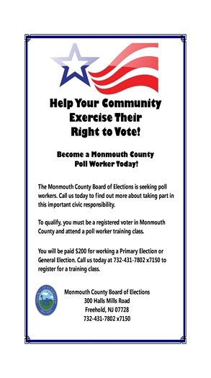
Help Your Community Exercise Their Right to Vote! Click the picture to apply to become a Monmouth County Poll Worker!

March 2018 Garbage, Recycling &
Bulk Collection Calendar

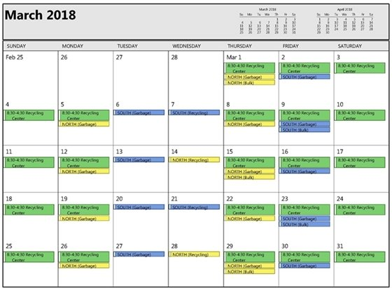
Click the picture to view the March garbage and recycling collection calendar!

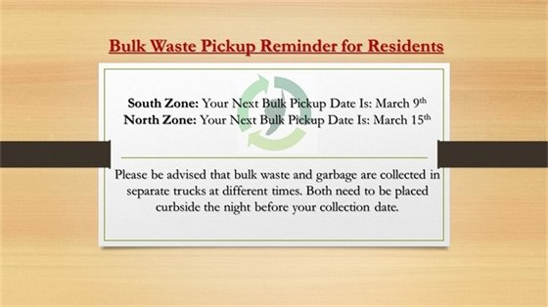
Click the picture to read more about Garbage, Recycling & Bulk Collection

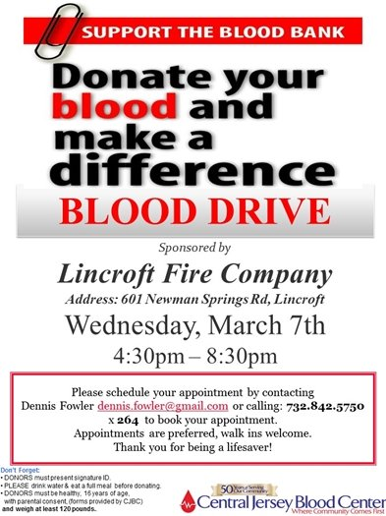

Middletown Township and New Jersey Natural Gas to Provide Free Energy Audits to Income-Qualified Residents
Middletown Township and New Jersey Natural Gas (NJNG) announced a pilot program to provide free energy audits to income-eligible residents. The program is designed to help qualified NJNG customers in Middletown identify energy-efficiency opportunities to help lower their energy bills.
Those who are not eligible based on their income can still sign up for a Comprehensive Home Energy Audit Analysis for $250 and receive a free ecobee4 Smart Thermostat.
Click HERE to read the press release.



Click the picture to learn more or to fill out an application!

Stay up-to-date on the latest news and events from
Middletown Town Hall...

Click the links to go to the page and follow/ subscribe!

Facebook Twitter Instagram Youtube

Verizon FiOS Channel 26/Comcast Cable Channel 20

  Share on Facebook
  Share on Twitter
  Share via Email

  Copyright 2015 Middletown NJ. All Rights Reserved.
  1 Kings Highway, Middletown, NJ 07748
  Powered by

