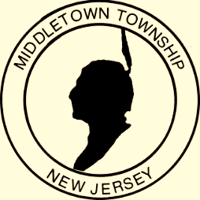
Proclamation
Office of the Mayor



WHEREAS: Middletown Township includes older Americans who richly contribute to our community; and
WHEREAS: We acknowledge that what it means “to age” has changed for the better; and
WHEREAS: Middletown Township is committed to supporting older adults as they take charge of their health, explore new opportunities and activities, and focus on independence; and
WHEREAS: We appreciate the value of inclusion and support in helping older adults successfully contribute to and benefit from their communities; and
WHEREAS: Our community can provide opportunities to enrich the lives of individuals of all ages by involving older adults in the redefinition of aging in our community; promoting home and community-based services that support independent living; encouraging older adults to speak up for themselves and others; and providing opportunities for older adults to share their experiences. Now
THEREFORE: I, Mayor Stephanie C. Murray and the Middletown Township Committee do hereby proclaim May 2018 to be Older Americans Month. We urge every resident to take time during this month to acknowledge older adults and the people who serve them as influential and vital parts of our community.
Given, under my hand and the Great Seal of the Township of Middletown,
this sixteenth day of April in the year two thousand eighteen

____________________________________ M Mayor Stephanie C. Murray

