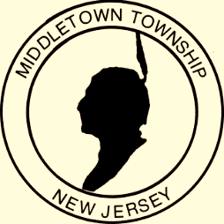

Proclamation
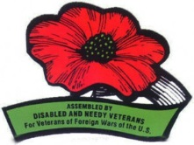
Office of the Mayor

Buddy Poppy Month
May 2018
WHEREAS: The annual distribution of Buddy Poppies by the Veterans of Foreign Wars of the United States has been officially recognized and endorsed by governmental leaders since 1922; and
WHEREAS: Buddy Poppies are assembled by disabled veterans, and the proceeds of this worthy fundraising campaign are used exclusively for the benefit of disabled and needy veterans, and the widows and orphans of deceased veterans; and
WHEREAS: The purpose of the sale of Buddy Poppies by the Veterans of Foreign Wars is eloquently reflected in the desire to “honor the dead by helping the living.” The 2013 Buddy Poppy Drive is being held during the month of May; and
WHEREAS: The Middletown VFW 2179 and its Ladies Auxiliary promote the sale of the Buddy Poppy through programs, hospital visits, and parties at the Menlo Park Veterans facility. They distribute funds raised to individuals living there; and
WHEREAS: We urge all patriotic citizens to wear a Buddy Poppy as a symbol of gratitude to the men and women of this country who have risked their lives in defense of the freedoms which we continue to enjoy as American citizens. Now,
THEREFORE: I, Mayor Stephanie C. Murray and the Middletown Township Committee do hereby proclaim that May 2018 is Buddy Poppy Month in Middletown Township. We hereby urge the citizens of this community to recognize the merits of this cause by contributing generously to this invaluable program.

Given, under my hand and the Great Seal of the Township of Middletown,
this sixteenth day of April in the year two thousand eighteen

________________________________________
Mayor Stephanie C. Murray

