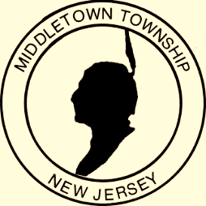

Proclamation
Office of the Mayor

Municipal Clerks Week 2018

WHEREAS: The Office of the Municipal Clerk, a time honored and vital part of local government, exists throughout the world; and

WHEREAS: The Office of the Municipal Clerk is the oldest among public servants; and

WHEREAS: The Office of the Municipal Clerk provides the professional link between the citizens, the local governing bodies, and agencies of government at other levels; and

WHEREAS: Municipal clerks have pledged to be ever mindful of their neutrality and impartiality, rendering equal service to all; and

WHEREAS: The Municipal Clerk serves as the information center on functions of local government and community; and

WHEREAS: Municipal clerks continually strive to improve the administration of the affairs of the Office of the Municipal Clerk through participation in education programs, seminars, workshops, and the annual meetings of their state, province, county and international professional organizations; and

WHEREAS: It is most appropriate that we recognize the accomplishments of the Office of the Municipal Clerk. Now

THEREFORE: I, Mayor Stephanie C. Murray and the Middletown Township Committee do recognize the week of May 6, 2018 through May 12, 2018 as Municipal Clerks Week, and further extend appreciation to our Township Clerk Heidi R. Brunt and to all Municipal clerks for the vital services they perform and their exemplary dedication to the communities they represent.

Given, under my hand and the Great Seal of the Township of Middletown,
this sixteenth day of April in the year two thousand eighteen

________________________________________
Mayor Stephanie C. Murray

