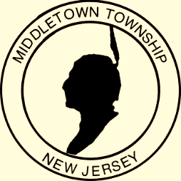

Proclamation
Office of the Mayor

National Volunteer Month
April 2018

WHEREAS: Middletown Township is well known for its spectacular volunteer spirit. A large measure of Middletown’s strength, beauty, and unique character is derived from the outstanding contributions made by thousands of residents who volunteer and play a vital role in many organizations and groups; and

WHEREAS: Residents who volunteer their time provide assistance which cannot be measured in terms of dollars. When people reach out to help one another, their support and positive actions multiply in value; and

WHEREAS: Residents also donate a significant amount of time in helping the Township of Middletown through their service on nearly two dozen Township boards, committees and commissions; and

WHEREAS: Volunteers throughout the Township of Middletown donate their time to a wide variety of programs such as the arts and recreation, youth athletic leagues, and programs that continue to help residents recover from devastating storms; and

WHEREAS: Volunteers provide vital emergency services through the all-volunteer Emergency Medical Service Department, Fire Department, Police Auxiliary and Emergency Management; and

WHEREAS: The Mayor and Township Committee extend their deepest gratitude to the fine men and women who generously donate their time to the community. Now,

THEREFORE: I, Mayor Stephanie C. Murray and the Middletown Township Committee do hereby proclaim April 2018 as National Volunteer Month in the Township of Middletown. We encourage everyone to recognize, support and commend these special volunteers.

Given, under my hand and the Great Seal of the Township of Middletown,
this second day of April in the year two thousand eighteen

______________________________________
Mayor Stephanie C. Murray

