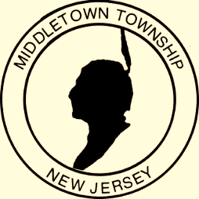

Proclamation
Office of the Mayor

Police Week 2018

WHEREAS: The Congress and President of the United States have designated the week of May 14, 2018 through May 18, 2018 as National Police Week; and
WHEREAS: The members of the Township of Middletown Police Department play an essential role in safeguarding the rights and freedoms of the Township of Middletown; and

WHEREAS: All citizens should know and understand the duties, responsibilities, hazards, and sacrifices of their law enforcement agency. It is also important that members of our law enforcement agency recognize their duty to serve the people by safeguarding life and property, protecting them against violence and disorder, and by protecting the innocent against deception and the weak against oppression; and

WHEREAS: The men and women of the Middletown Police Department unceasingly provide a vital public service. Now,
THEREFORE: I, Mayor Stephanie C. Murray and the Middletown Township Committee proclaim that the week of May 14, 2018 through May 18, 2018 is designated as Police Week in the Township of Middletown. We call upon all citizens and patriotic, civic and educational organizations to observe this week with appropriate ceremonies and observances in which all of our people may join in commemorating law enforcement officers, past and present. By their faithful and loyal devotion to their responsibilities, these individuals have rendered a dedicated service to their communities and have established for themselves an enviable and enduring reputation for preserving the rights and security of all citizens.

Given, under my hand and the Great Seal of the Township of Middletown,
this second day of April in the year two thousand eighteen

________________________________________
Mayor Stephanie C. Murray

